DQL 2

- Display the average, lowest, highest and difference in lowest and highest salaries for each department number.

select avg(sal) "Avg Salary", min(sal) "Min Salary", max(sal) "max Salary" , max(sal) - min(sal) "Difference"
from emp
group by deptno;

- Display the number of employees within each job.

select job, count(empno) "Number of Employees"
from emp
group by job;
- Display only those jobs where the minimum salary is greater than or equal to 3000.

select job, min(sal)
from emp
group by job
having min(sal) >= 3000;

- Calculate and display only the average salaries paid to all those employees where the employee name starts with A and name starts with S.

select avg(sal) "Avg Salary"
From emp
where ename like 'A%' or ename like 'S%';

- Product exactly same output as shown below:

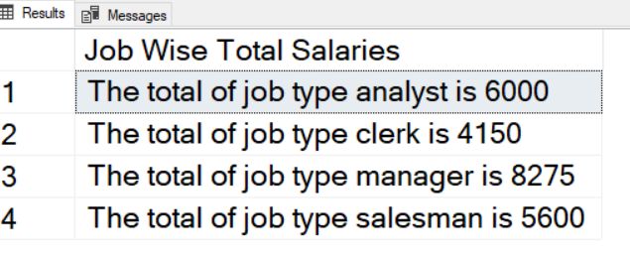

Select 'The total of job type ' || job || ' is ' || sum(sal) "Job Wise Total Salaries"
From emp
Group By job
Having count(1) > 1
Order By job;

OPTIMIZED SOLUTION

Select 'The total of job type ' || job || ' is ' || sum(sal) "Job Wise Total Salaries"
From emp
Where job <> ‘PRESIDENT’
Group By job
Order By job;

- Product exactly same output as shown below:

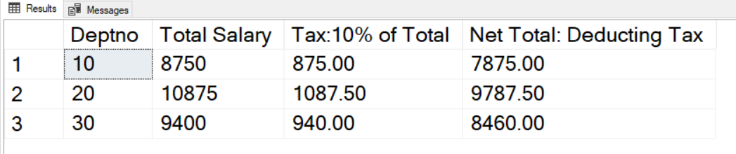

Select Deptno "Deptno",
sum(sal) "Total Salary",
sum(sal)*0.1 "Tax",
round(sum(sal) - sum(sal)*0.1,2) "Net Total: Deducting Tax"
From emp
Group By Deptno
Order BY 1;

